**ASSIGNMENT - 4**

**Docker and Kubernetes**

|  |  |
| --- | --- |
| Project Name | Smart Fashion Recommender Application |
| Team ID | PNT2022TMID07960 |

**1.Pull an image from docker hub and run it in docker Playground**

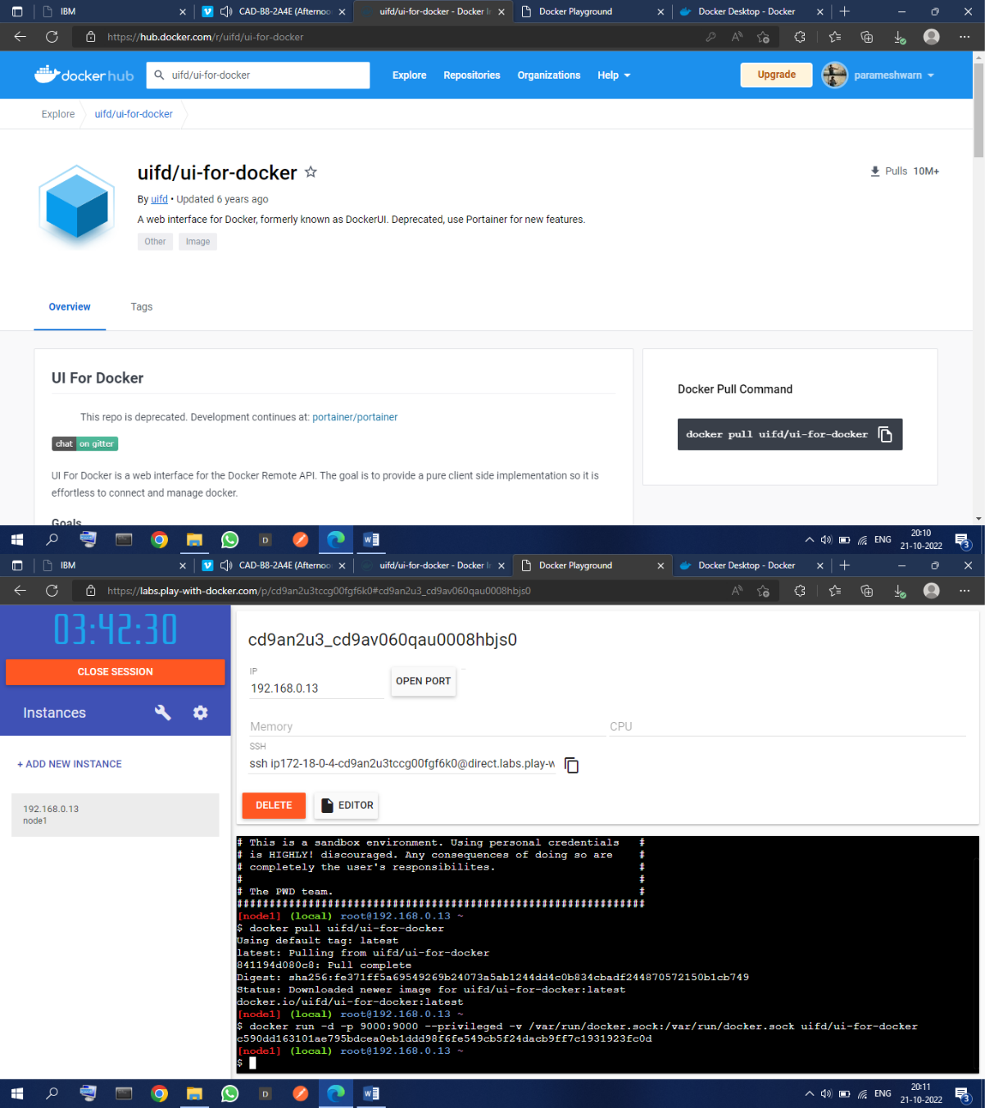

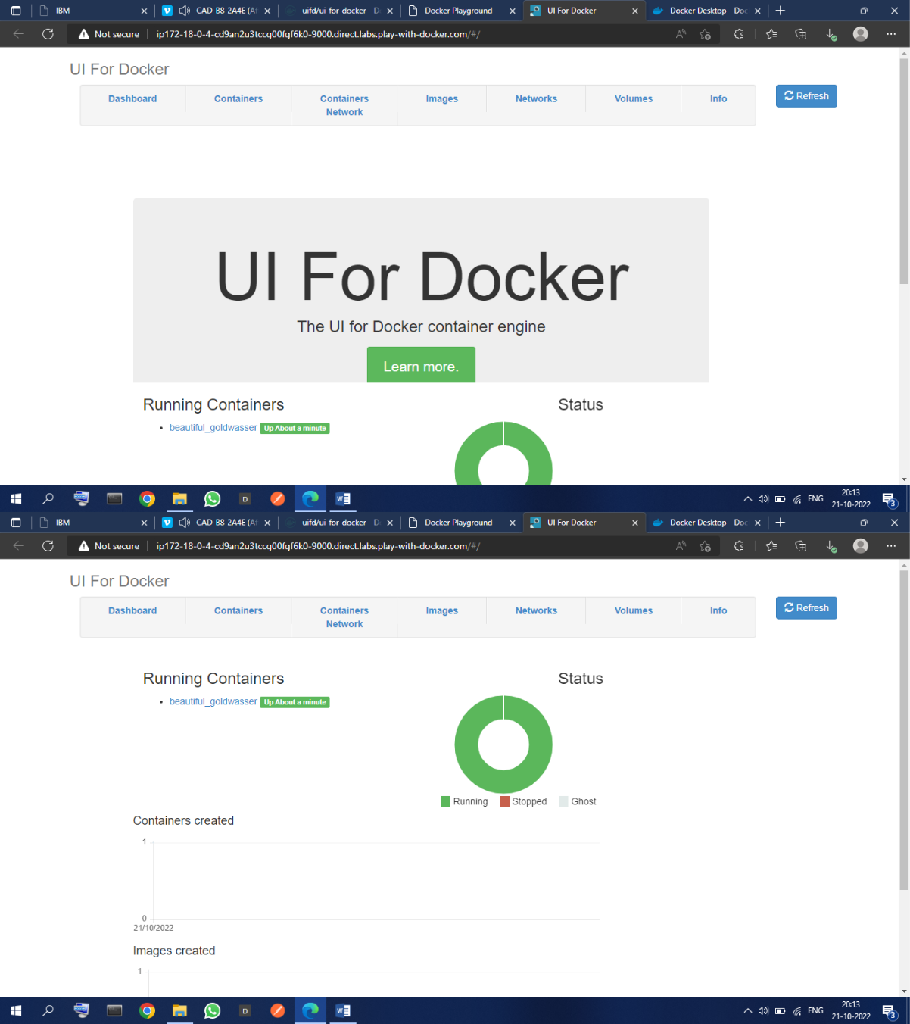

**2.Create a docker file for the job portal application and deploy it in Docker desktop application**

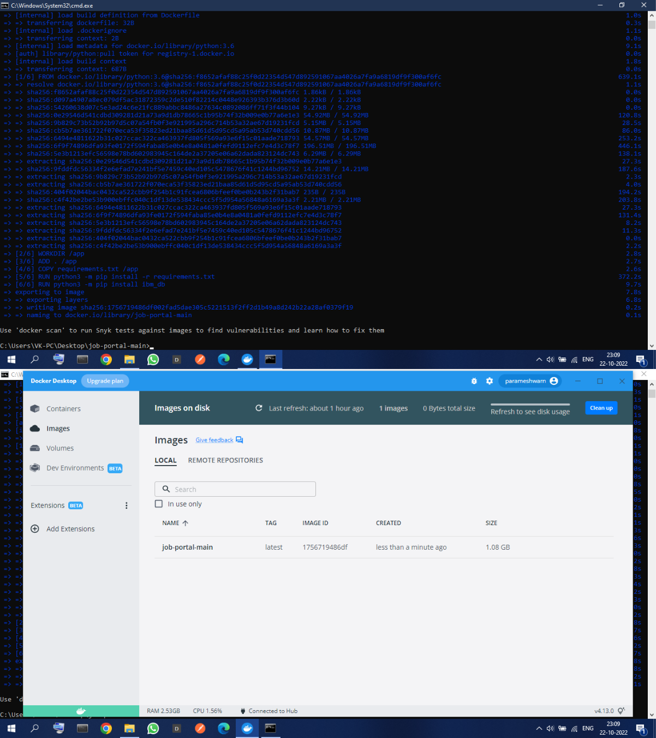

**3.Create a IBM container registry and deploy helloword app**